Project Report: Translator Buddy
Domain: Artificial Intelligence & Natural Language Processing
Specialization: Literary Translation
Course: Programming for AI
Author: Anas Faiz
Registration No: 2023-CS-26

Project Overview and Domain
Translator Buddy is a context-aware AI translation ecosystem powered by Google's Gemini API (gemini-3.5-flash). Unlike standard Neural Machine Translation (NMT) systems, this project operates in the domain of literary and context-driven translation. It is explicitly engineered to handle the complex, flowing prose characteristic of classic world literature using tailored system prompts and persona routing.

Problem Statement
Modern translation tools like Google Translate are highly accessible but fail to meet the needs of academic and literary users due to several core limitations:
- Lack of Stylistic Control: Standard tools translate literally, stripping away the melancholic depth, gritty realism, or poetic nuance required for literary texts..
- Context: Standard translation tools lack context, they treat each individual input as a singular object, while our project keeps the context and molds the results accordingly
- PDF Extraction Friction: Students frequently read research papers in Chrome's native PDF viewer, which blocks standard text-scraping extensions. Translating these requires tedious copy-pasting between tabs.
- Data Privacy & Connectivity: Cloud-based APIs require constant internet access and send potentially confidential documents to third-party servers.
Translator Buddy solves these issues by leveraging a FastAPI backend service paired with the Gemini API for translation generation, providing a dedicated Next.js web application for sustained literary work, and a Chrome extension that bypasses PDF restrictions via the Context Menu API to translate text directly alongside documents.

Functional Requirements
- Bi-directional Translation: The system must translate both English-to-Urdu and Urdu-to-English with equal accuracy.
- Context/Tone Injection: Users must be able to specify a desired tone (e.g., "Gritty realism", "Formal") which the model must adopt dynamically.
- Persistent History: The web application must maintain a localized, sliding-window history of the user's last 3 interactions to provide the LLM with conversational context.
- PDF Integration: A browser extension must capture highlighted text from local or web-based PDFs and stream the translation into a side panel.
- API Integration & Persona Routing: All translation requests must be dynamically routed through the FastAPI layer to dedicated Gemini API persona prompts based on translation direction and context.

Implementation Plan
The project follows a phased, full-stack deployment strategy on a Pop!_OS Linux environment:
- Phase 1: Prompt & Persona Configuration: Configure system prompts and persona definitions (Persona A: EN to UR and Persona B: UR to EN) utilizing few-shot prompting with explicit rules for acronym preservation and fluent literary translation.
- Phase 2: Backend API Development: Construct a FastAPI routing layer on port 8000. Implement HTTP POST endpoint handling to intercept translation payloads, format system prompts with style context, and make API calls to Gemini (gemini-3.5-flash).
- Phase 3: Web Application (Next.js): Build a responsive, React-based interface with a symmetric UI, integrating text inputs, dynamic Left-to-Right / Right-to-Left formatting, and local storage history management.
- Phase 4: Chrome Extension Development: Utilize Chrome Manifest V3 to build a Side Panel extension. Implement the Context Menu API to capture highlighted text from Chrome’s restricted native PDF viewer and route it to the FastAPI backend.
- Phase 5: Testing & Prompt Refinement: Conduct edge-case testing on long paragraphs, technical jargon, and colloquial idioms to refine the system prompt few-shot examples and stop conditions.

System Architecture
The system utilizes a client-server architecture orchestrating multiple user interfaces, an API routing layer, telemetry stack, and the Gemini API service. The core components comprise a FastAPI backend, a Next.js web application, a Chrome extension for browser PDF extraction, and an integrated Prometheus/Grafana monitoring suite.
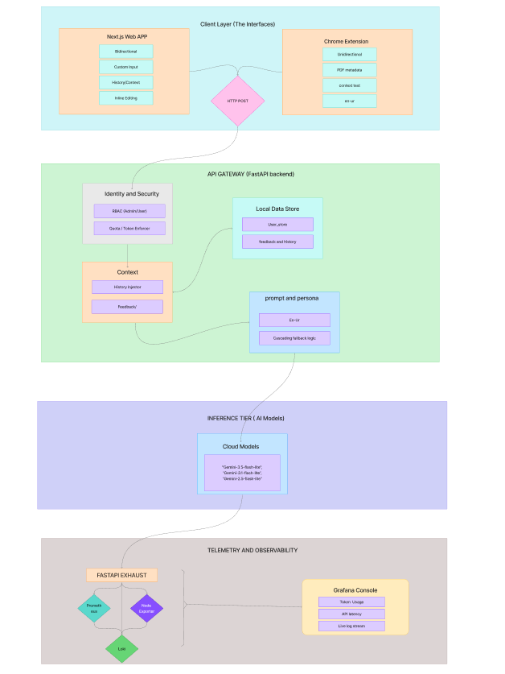

Core Flow:
- Client (Next.js or Chrome Extension) sends a payload {text, direction, context, history}.
- FastAPI intercepts the payload, formats the strict prompt, and evaluates the direction flag.
- FastAPI routes the request to either Persona A (EN to UR) or Persona B (UR to EN) system prompt configurations for API execution.
- Gemini (gemini-3.5-flash) processes the translation query and returns the formatted response.

Component Breakdown

- FastAPI Backend API: Operates as the central routing hub (port 8000). Handles payload interception, dynamic persona prompt formatting, sliding-window history injection, and rate limiting.
- Next.js Web Frontend: Provides a symmetric user interface with support for bi-directional text alignment (LTR/RTL), tone selection, and persistent conversation context management.
- Chrome Extension: Employs Manifest V3 and the Side Panel / Context Menu APIs to capture highlighted text from restricted web and local PDF viewers.
- Telemetry & Monitoring Stack: Integrates Prometheus metrics collection and Grafana dashboards for monitoring API latency, request rates, token usage, and endpoint health.
- Dynamic Persona Ingestion: Instead of a generic prompt, incoming requests execute against strict direction-specific prompts:
EN_UR_SYSTEM_INSTRUCTION: Prioritizes natural cadence, poetic syntax, metaphorical preservation, and Latin script preservation for English acronyms (e.g., UET, API, FYP).
UR_EN_SYSTEM_INSTRUCTION: Reconstructs Urdu muhavray (محاورے) into articulate English prose, converting contextual address markers (Janab, Sahib) into natural English dialogue without mechanical transliteration.
- Cascading Model Fallback: To ensure a trustworthy uptime i have used fallback mechanism to ensure that the API calls does not exhaust the quota and stop responding
"Gemini-3.5-flash-lite",
“Gemini-3.1-flash-lite”,
“Gemini-2.5-flash-lite”

Security Considerations & Operations Guide
- API Security: Gemini API credentials and secrets are managed via environment variables within the FastAPI service, avoiding client-side key exposure.
- PDF Access Permissions: Local PDF translation via the Chrome Extension requires explicit user enablement of "Allow access to file URLs" in browser settings.
- Deployment & Operations: System services run under Linux (Pop!_OS) using Uvicorn for FastAPI backend service management, Node.js process managers for Next.js, and Docker containers for Prometheus/Grafana stack orchestration.

Use Cases

- Web Literature translation tool: A dedicated literature focused web translation tool, for anyone who wants to better understand a paragraph or single line from a literary content.
- The Literature Student/Author: A writer translating a chapter of an English novel into Urdu. They use the Web App, inputting "Melancholic, flowing prose" into the Context field to ensure the translation matches the emotional weight of the original text, while using the history sidebar to maintain narrative consistency.

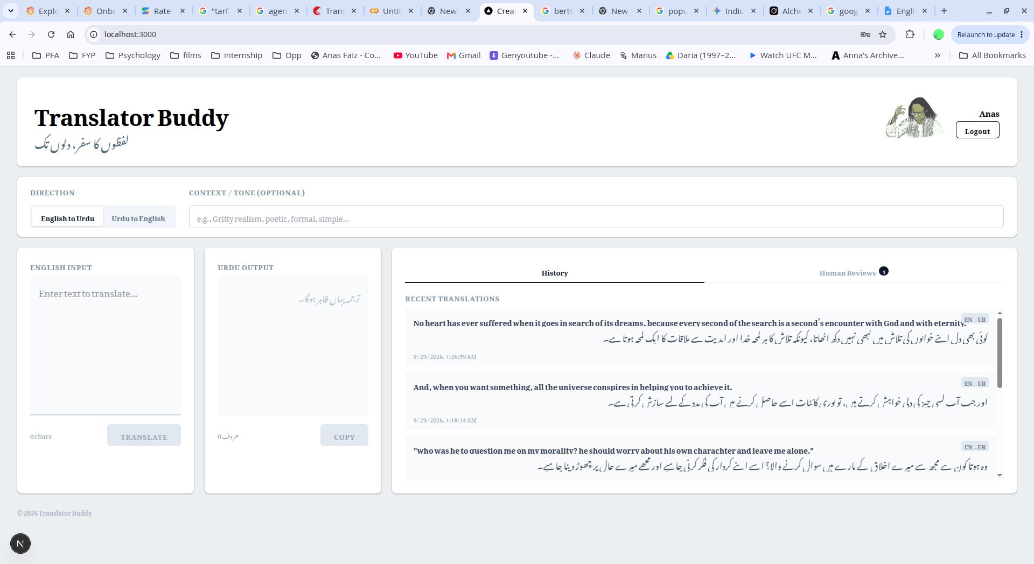

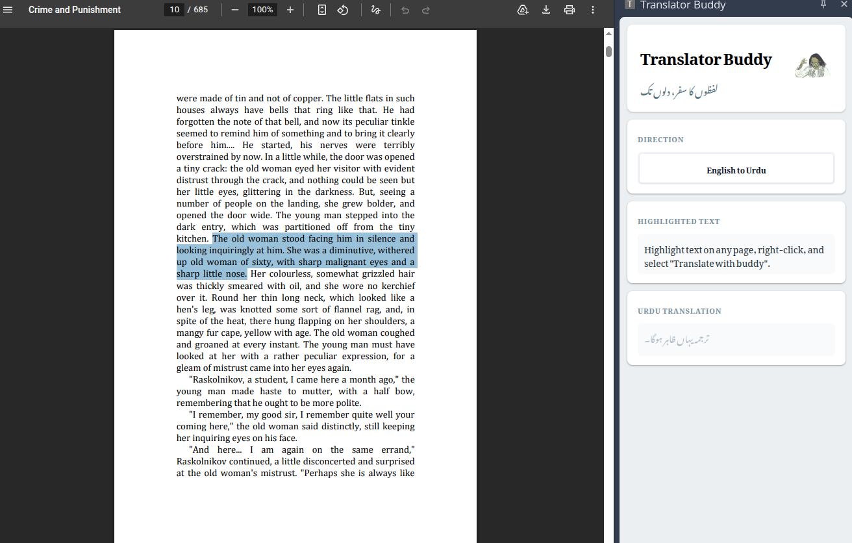

Quantitative Verification & Evaluation: Translator Buddy vs. Google Translate
Standard NMT evaluation relies on the BLEU metric. However, BLEU measures strict $n$-gram lexical overlap. In literary translation, BLEU penalizes idiomatic and poetic paraphrasing because it rewards mechanical, word-for-word substitution.
To scientifically evaluate semantic and emotional fidelity, this study benchmarks outputs against published human translations using BERTScore (bert-base-multilingual-cased).

Benchmark Dataset: The Alchemist by Paulo Coelho
- Human Reference (Gold Standard): Translated into literary Urdu (ال کیمسٹ) by renowned translator Umar Ghazali.
- Evaluation Pipeline: Evaluated using Google Colab running PyTorch, HuggingFace Transformers, and the official bert-score evaluation harness.
Source Text | Actual Alchemist translated by Umar Ghazali | Google Translate Output | Translator Buddy Output | Analysis / Notes
And, when you want something, all the universe conspires in helping you to achieve it. | اور جب تم کچھ چاہتے ہو، تو ساری کائنات تمہاری مدد کرنے کے لیے سازش کرتی ہے۔ | اور جب آپ کسی چیز کی خواہش کرتے ہیں، تو پوری کائنات اسے حاصل کرنے میں آپ کی مدد کے لیے سازگار ہو جاتی ہے۔ | اور جب آپ کسی چیز کی دلی خواہش کرتے ہیں، تو پوری کائنات اسے حاصل کرنے میں آپ کی مدد کے لیے سازش کرتی ہے۔ | BERTtScore:  Google Translate F1 Score: 0.8259  Translator Buddy F1 Score: 0.8485
No heart has ever suffered when it goes in search of its dreams, because every second of the search is a second’s encounter with God and with eternity. | کوئی دل کبھی تکلیف نہیں اٹھاتا جب وہ اپنے خوابوں کی تلاش میں نکلتا ہے، کیونکہ تلاش کا ہر لمحہ خدا اور ابدیت سے ملاقات کا لمحہ ہوتا ہے۔ | اپنے خوابوں کی تلاش میں نکلنے پر کسی دل کو کبھی کوئی دکھ نہیں پہنچا، کیونکہ اس تلاش کا ہر لمحہ خدا اور ابدیت سے ایک ملاقات کا لمحہ ہوتا ہے۔ | کوئی بھی دل اپنے خوابوں کی تلاش میں کبھی نہیں دکھ اٹھاتا، کیونکہ تلاش کا ہر لمحہ خدا اور ابدیت سے ملاقات کا ایک لمحہ ہوتا ہے۔ | BERTScore:  Google Translate F1 Score: 0.8985  Translator Buddy F1 Score: 0.9263

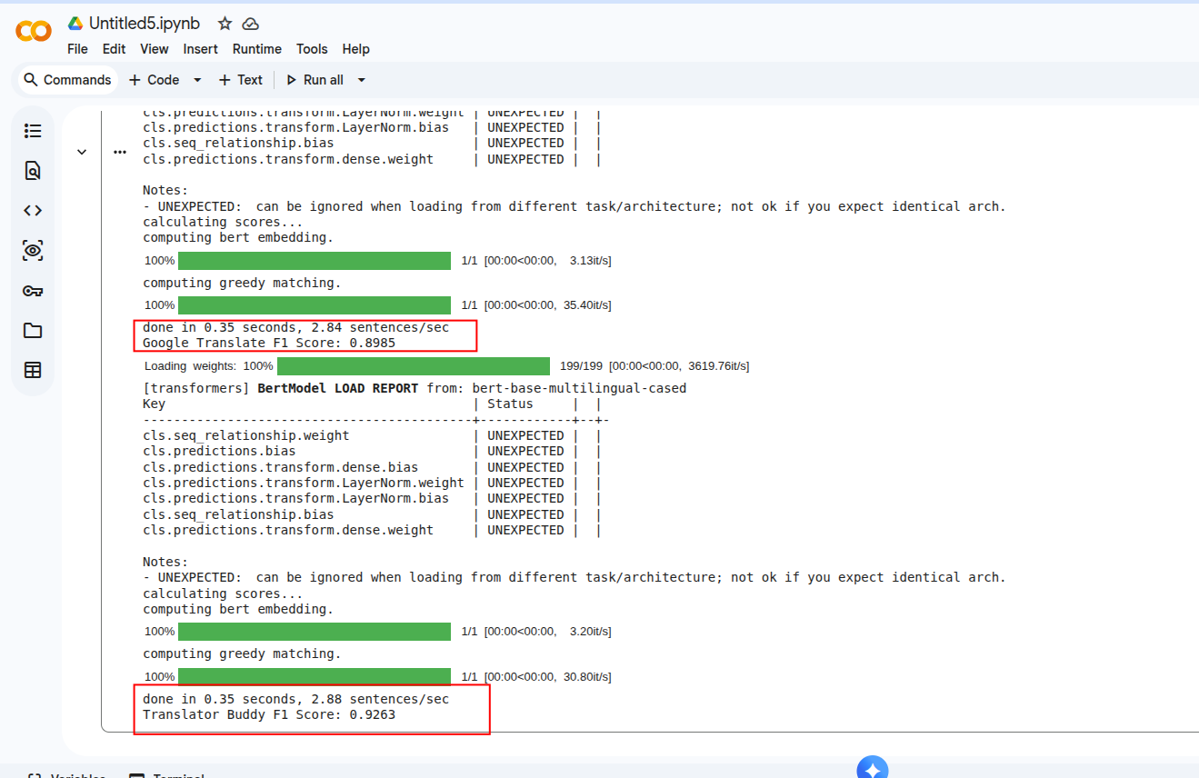

Value Proposition: Why Choose Translator Buddy?

- Steerable Personas via Gemini API: Unlike standard tools, Translator Buddy leverages custom system prompts on the Gemini API (gemini-3.5-flash) to adapt dynamically to specific tone, style, and literary demands.
- Efficient FastAPI Architecture: A centralized FastAPI backend service manages persona routing, context injection, and sliding-window history between clients and LLM endpoints.
- Multi-Interface Access: Seamless workflow provided through a dedicated Next.js web application for deep literary translation and a Chrome Side Panel extension to bypass browser PDF restrictions.
- Better Literary style Results: Translator Buddy has shown significantly better results in translating literature based artifacts than google translate as you can see in the quality assurance section.

User Identity, Quota Management & Administrative Telemetry
To ensure sustainable scaling and prevent API abuse, Translator Buddy implements a centralized identity and token accounting subsystem. This allows administrators to monitor granular application usage beyond global system metrics.

Role-Based Access Control (RBAC) & Authentication
The backend enforces role-based identity management, categorizing accounts into standard user and admin tiers. All translation endpoints require a valid session or authentication token, allowing the system to map every API request to a specific user UUID.

Token Accounting & Quota Enforcement
Because foundation models charge or rate-limit based on token volume, the system actively intercepts and logs the usage_metadata returned by the Gemini API on every translation turn.
- Per-User Tracking: Input tokens (prompt context + history) and output tokens (generated translation) are tallied and written to the user's profile state in the backend store.
- Rate Limiting: Administrators can define daily token ceilings for standard users. If a user exceeds their quota, the FastAPI layer intercepts the request with an HTTP 429 (Too Many Requests) error, protecting the system from runaway cloud costs.

Admin Observability Console
The administrative controls are deeply integrated into the Grafana telemetry stack.
- Custom Prometheus queries track API consumption mapped by user identity.
- Administrators have access to a dedicated dashboard visualizing Top Token Consumers, Daily Active Users (DAU), and Error Rates per User, providing a clear overview of individual application usage patterns versus global infrastructure load.
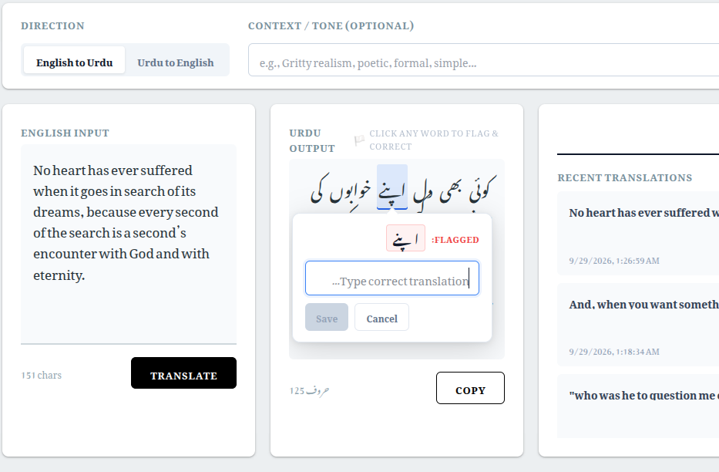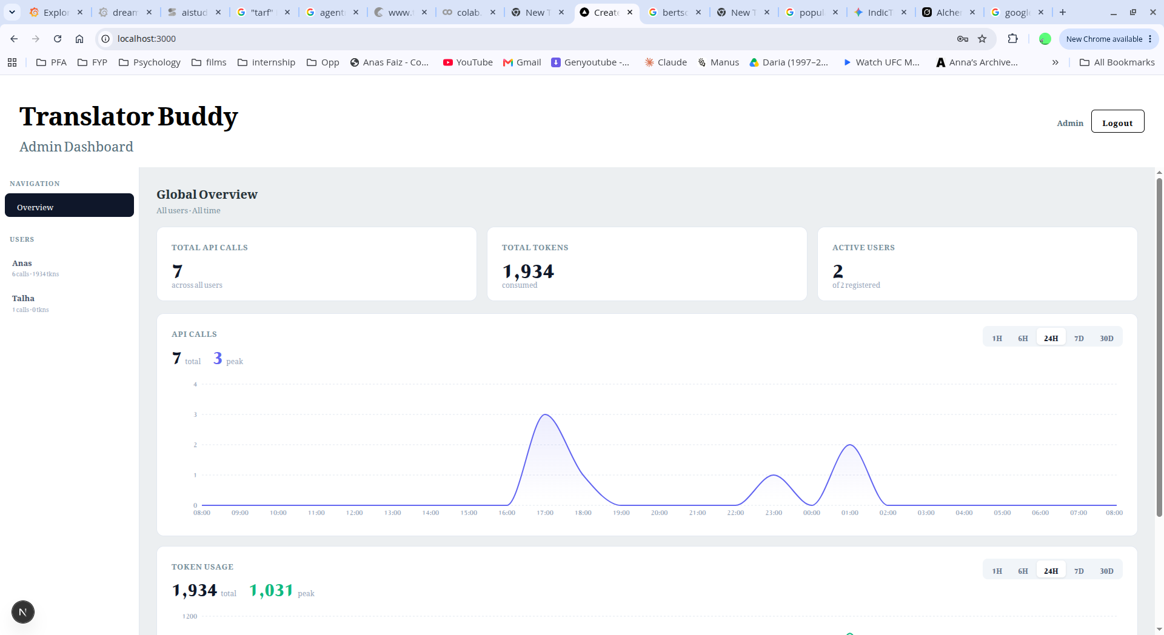

Test Cases and Edge Cases

Test Case | Description | Expected Outcome | Actual Result (Pass/Fail)
FastAPI Persona Routing | Send request to FastAPI with direction flag "en-ur" vs "ur-en". | Backend selects Persona A for EN-to-UR and Persona B for UR-to-EN. | Pass
Acronym Preservation | Input containing "UET", "FYP", "API". | Urdu script surrounds intact English Latin letters. | Pass
Context & Tone Injection | Specify "Gritty realism" or "Melancholic, flowing prose" in Context field. | Gemini API dynamically adapts output phrasing to requested literary tone. | Pass
Next.js Sliding-Window History | Perform 5 consecutive translations in Web App. | App stores last 3 interactions in local storage for conversational LLM context. | Pass
Chrome Extension PDF Extraction | Highlight text in Chrome native PDF viewer and right-click. | Context Menu API captures text and streams translation to Side Panel. | Pass (Requires enabling 'Allow access to file URLs' for local PDFs).
Context Window Overflow | User highlights 3 full pages of text at once. | Model processes the text successfully without hallucination. | Fail (Known Limitation): Highlighting massive blocks exceeds token limits or causes request timeouts. Requires chunking.
Stop Token Adherence | Standard English-to-Urdu translation via Gemini API. | Output ends cleanly with no hallucinations like (Urdu: "..."). | Pass (Resolved via few-shot rules and stop token configuration).

Dynamic Context & Correction Engine
Standard LLM wrappers process queries as isolated, memoryless events. Translator Buddy introduces two contextual grounding loops:
- Sliding-Window Conversational Memory: The web interface maintains a localized cache of the prior 3 translation turns. This enables the foundation model to track recurring character names, pronouns, and established terminology across continuous literature translation.
- Correction Injection (RAG-Lite): When users submit corrections via the UI, adjustments are persisted to an indexed store (feedback_store.json). Subsequent API payloads inject relevant historical corrections directly into the dynamic prompt block, ensuring the engine continuously aligns with user preferences.

Full-Stack Telemetry and Observability Plane
The production stack implements an enterprise monitoring suite deployed via Docker Compose to manage performance, resource contention, and fault isolation.
Telemetry Services Matrix:
Component | Ingestion Target / Source | Scrape / Push Frequency | Port | Responsibility
Prometheus | FastAPI (:8000/metrics), Node Exporter (:9100) | 15s Scrape Interval | 9090 | Time-series metric aggregation & anomaly tracking
Grafana | Prometheus (:9090), Loki (:3100) | Real-time Query Polling | 3001 | Unified operations and observability visualization
Node Exporter | Pop!_OS Kernel / Host Hardware Subsystem | Real-time Daemon | 9100 | Hardware metrics: CPU, RAM, Disk I/O, Network saturation
Grafana Loki | Promtail Agent Ingestion Stream | Continuous Push Chunking | 3100 | High-efficiency, index-compressed log aggregation
Key Operational Metrics Tracked
- http_requests_total{handler="/translate", status="200"}: Measures translation throughput segmented by language direction (en-ur vs ur-en).
- http_request_duration_seconds{quantile="0.95"}: Tracks tail latency (P95) to catch slow network hops to Gemini API endpoints.
- node_cpu_seconds_total: Monitors host CPU saturation during concurrent model requests.
- node_memory_MemAvailable_bytes: Tracks RAM to ensure zero memory exhaustion on the host machine.
